# Prospect-R Site and Administration Guide

## Table of Contents:

## The Site

### Header

### Logging In

### About

### Before you get started...

### FAQ

### Homepage

### Page Layout

### Map Panel

### All Sites

### Creating A New Site

### Drawing

### Editing

### Site Details

### Creating/Editing Pits

### Survey

### Report Summary

### Full Report

### Printable Report

## Site Administration

### Accessing the Admin Site

### Authentication and Authorization

### Flatblocks

### Survey

### Survey - Questions

### Order: Context, Category, Question

## The Site: Prospect-R

Prospect-R is a tool for determining a gravel pit mine's viability for restoration. Using open source software, this tool was custom built for The Nature Conservancy by Ecotrust. It employs many cutting-edge technologies and methodologies to bring a science-based approach for decision making.

Users of Prospect-R will be able to register, log in, enter data about any given gravel pit, and receive a report detailing its viability for restoration. They can print out their results to share or save them as a .pdf.

Using Bayesian logic, the tool is able to determine how likely a site is to be worth restoration even when not all information about the site is available. Note that it's a still probabilistic model, and will return a better answer with more data.

### Header

The page's header will stay fairly consistent during the entire site's workflow, only a few elements will change as they become or stop being relevant to the user's experience.

#### Site Name:



First and foremost is the site name and graphic. At any time while using the tool a user may click here and return to the title page (covered later).

#### Gravel Pit Site Name



If the user has a gravel pit site selected and are actively working on or viewing it, its name will be promptly displayed next to the Site Name.

#### Site Menu:

#### 

The Site Menu allows easy navigation for managing several gravel pit sites at once.

* 'Documents' - brings the user to a page listing useful documents they may wish to reference for answering questions about their gravel pit
* 'Add a site' - lets users add a new site to their project portfolio
* '{Site Name}' - in this case, 'Gravel Pit Site', an entry for every site the user creates will be in this list to quickly and easily switch between managing them.
* 'All sites' - Brings the user to the 'All Sites' page (covered later) where they can browse their gravel pit mine site projects.

#### Questions Menu:

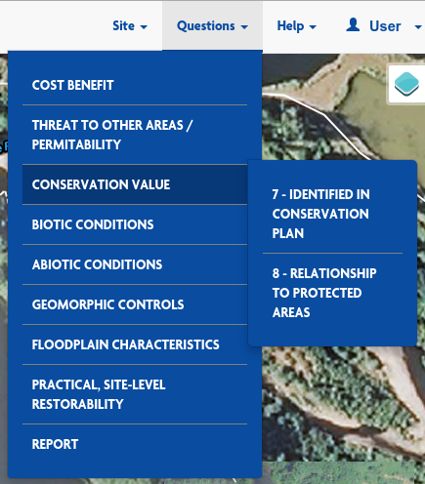

From the questions menu users will be able to access any of the survey questions as organized by their categories.

There is also one final item on the Questions Menuto allow the user to quickly reach their Report Page (once they've taken the survey).

#### Help Menu:

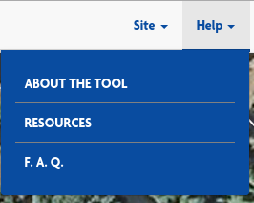

The Help Menu allows users at anytime access resources to help them in the event that they may have uncertainty about how to proceed with the tool.

#### User Menu:

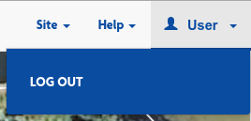

If logged in, the user's username will be printed here, otherwise it will simply read "Log In". Account-related actions (such as logging in or out) are accessable here.

### Logging In

Apart from the landing page and help pages, the rest of the site requires you to be a logged-in, registered user. The Accounts section has 3 different forms available to non-logged-in users: Log in, Reset Password, and Sign up/Register.

#### Sign Up:

Anyone is allowed to sign up. To register, simply access the accounts pages with the "Log in" button or the "Get Started" button on the home page. From the 'Log In' page, new users are directed to register via a link in the text, from the 'log in' menu in the header, or by clicking "I need to register" in the footer.

To sign up, a user only needs to provide a username, an optional email address, and a password for their own use. Once done, they will automatically be logged into the site, and if they provided an email address, they will receive a confirmation email. The user does not need to act on the confirmation email, but we will have records indicating whether a user has verified their email account or not.

#### Log In:

Once a user has registered with the site, they may log in at any time. The Log in page can be reached either from the Log In link in the header, or by clicking "Get Started" on the home page. Entering in their username and password will take them to their Sites page.

From the Log In page, users may also reach the Sign Up/Register page, or the Reset Password page.

#### Reset Password:

Users who do not remember their username or password can go to the Password Reset page, accessible from either the Sign Up or Log In pages. All they need to do is enter the email address they provided upon registration and they will be emailed instructions on how to reset their password and log in with their new credentials.

NOTE: supplying a password during registration is optional - if a user does not provide one, they will have no way to change their password, nor will they have a way to verify who they are to an administrator to change their password for them. Their only remaining options will be to try to remember their password or create a new account and start over.

### About

The about page is available to explain the purpose and audience of the site, as well as some of its functionality to all visitors, in case they don't know.

### Before you get started... / Documents

This page presents a list of documents and figures that will help users accurately answer the site's questions about their property and pits.

### FAQ

This page will be devoted to answering many of the most commonly asked questions about the site.

### Homepage

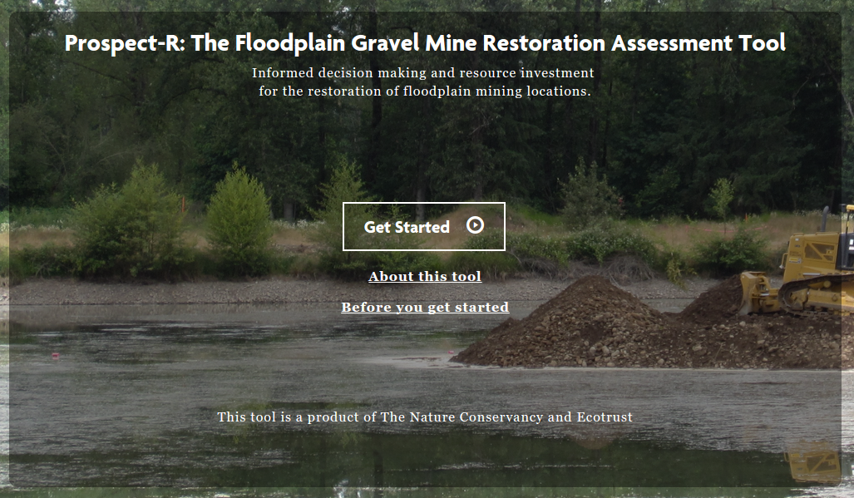

This is the default landing page for the site. It briefly conveys the purpose of the site and invites visitors to dig deeper, offering several links to further information and prominently displaying the path to "Get Started" with the site. It is reachable via link from almost every page in the tool.

### Page Layout

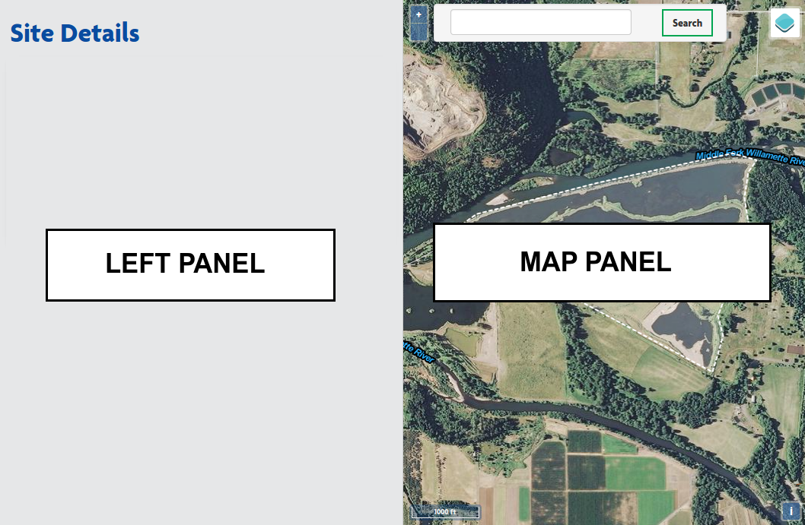

When users reach the All Sites page for their first time, they will be presented with the two primary components that drive most of the pages is this tool:

* The Left Panel - This panel provides context and all direction that users will need to get through the tool
* The Map Panel - This panel is a fully explorable map that will aid users in answering questions, and allow them to enter spatial information when that is requested. Mor on the map panel will be explained in its own section below.

### Map Panel

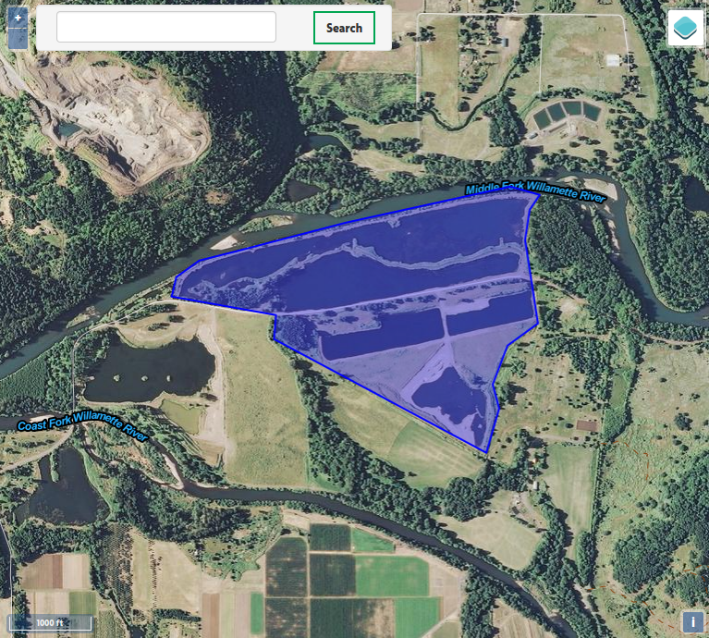

The map panel gets used for a variety of purposes. First and foremost it gives users quick and easy to understand context as to what geographic area they are answering questions for at any time (whether the question is about a pit mine or the site as a whole, etc...).



Map Controls: The '+' and '-' buttons relate to zooming in and out respectively. A user may also use the scroll-wheel on their mouse if they have one.

Panning or moving the map (left, right, up, down) is done by clicking and dragging with the mouse. There are no buttons for it.

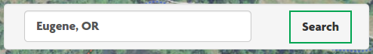

GeoSearch Bar: The search bar allows users to quickly navigate and zoom to nearby cities or landmarks.



Overlays: This button opens the overlay list on hover (more below)

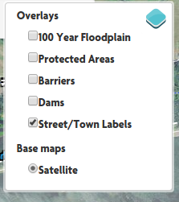

Overlay List: The checkboxes allow a user to add or remove layers from the map.

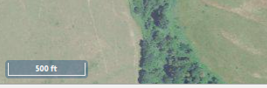

Scale Bar: In the bottom left, the user is given the scale of the map.



Attributions Button: Clicking this button opens the map's attributions display (below).



Attributions Display: A brief attribution of where map data is coming from.

### All Sites

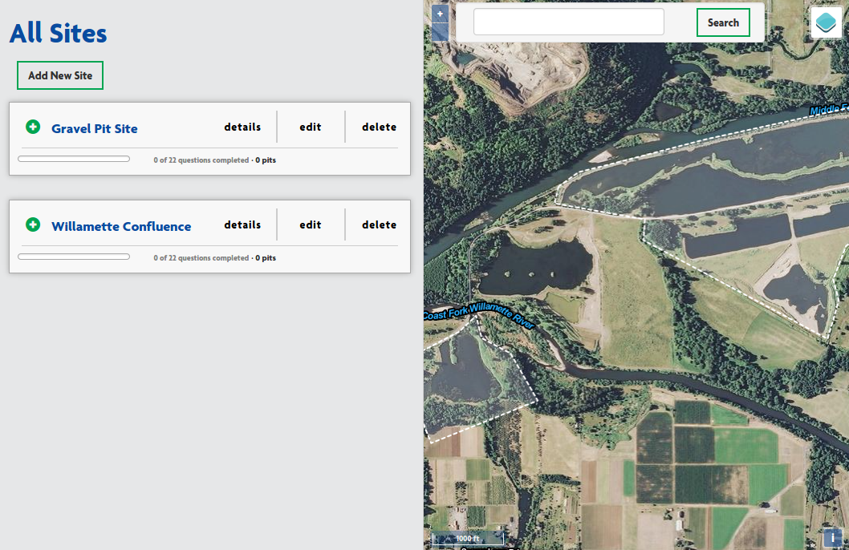

The left panel of this page provides users with a list of all of the site projects that they've entered into the tool. In this tool, a "Site" is a contiguous plot of land that encompasses one or more gravel pit mines.



If a user has not started any sites, they should click on the "Add New Site" to get started.

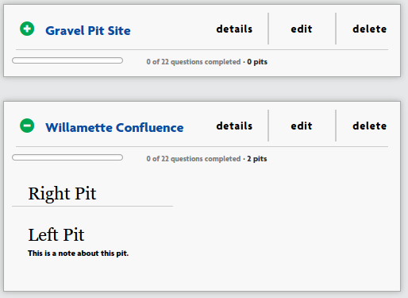

If the user has started one or more sites, they will see a list like this. All sites will show their name, progress toward answering questions about the sites, and have buttons for viewing, adding or editing information about the site.

Clicking on the site's name will display more information about it, such as what pits have been added to the site (see the 'Willamette Confluence example).

Clicking 'details' will bring you to the Site Details page (more below).

Clicking 'edit' will bring you to the Site edit page, where you can change the lines and name of your site (more on editing shapes later).

Clicking 'delete' will prompt you to confirm that you wish to delete the Site, including all pits, answers, and reports associated with it. Clicking 'OK' in the confirmation popup will instantly proceed with the deletion.

### Creating A New Site

This is the user's first chance to enter spatial data about their site. They will be drawing the geographic bounds of their site.

First, you will want to type in a name for your site. This name should be descriptive enough for you to know it from any of your other sites. It will show up in your reports, but is mostly used for reference. It does not have to reflect any official documentation.

After naming your site, you will need to draw out the boundaries for your site. Please note that 'Site' and 'Pit' are different: you will get to draw a boundary around any gravel pit mines you want assessed in later steps. For now, just choose a plot of ground big enough to cover your pits - some extra space around the pits is expected, and will make for clearer reports. If the property is much larger than just the gravel pits, PLEASE DO NOT TRACE THE ENTIRE PROPERTY. Just the area implicated in restoration plans is fine.

The actual drawing is covered in detail below.

Clicking Save will create your new site, which will add it to the "all sites" list mentioned earlier. Your site will not save if you have not drawn its boundaries like the example shown above, or if you have not given it a name. You will be prompted if you forget either of these.

Clicking "Cancel" will immediately discard any unsaved changes (no prompt). If you have not previously saved this site (as in, you are creating this site for the first time) then you will not have a site to show for it. If you are editing an existing, previously saved site (more details below) then you will only discard your newest, unsaved changes and revert to the original.

At the bottom, some helpful vocabulary and definitions are given to clarify any ambiguity in the tool's use of words:

**Site**: A contiguous plot of land that encompasses one or more pits.

**Pit**: A single gravel pit mine.

### Drawing

Drawing your bounds is relatively straighforward - just follow along the printed directions in the left panel on the map over your Site:

#### **Click anywhere on the map to start defining your general location boundary.**

#### Single click, in this case. You will want to actually click on your boundary to start, as wherever you click will be considered part of your site. Clicking inside of where you want to draw your boundary is a mistake that will become clear in the next step. **Continue clicking to complete the shape of your location.**

#### Each click will create a new 'corner' or 'vertex' for your shape. If you haven't done this before it sounds a bit confusing, but you'll get the hang of it quickly - just think of it as creating your own 'connect-the-dots' shape. As you click, you will see the border follow your mouse pointer.

#### In the screenshot below, the user is about 3/4 through drawing in a counter-clockwise pattern. Note that back-tracking or crisscrossing will leave you with a very distorted and useless shape. Always trace the outline, and "connect-the-dots" in that order.

#### There is no need to be perfect or overly detailed with the outlines. It's good enough if the boundary gives a general sense of the landscape, but this doesn't have to match survey lines.

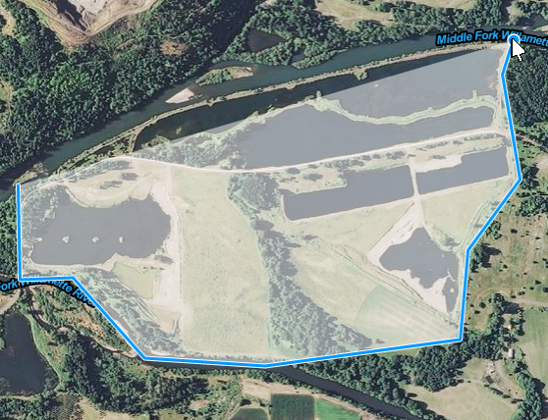

**When you're satisfied with your location outline, *double-click* to end drawing.**

You will know that you're done drawing when the shape is filled in with a transparent blue and the boundary line is no longer 'stuck' to your mouse pointer.

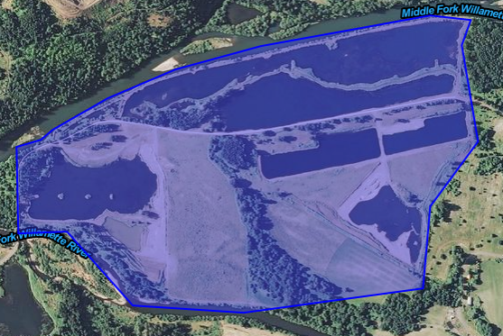

**Name and save your location when done. You can come back and edit this at any time.**

This is done by entering a name for your site (not a name for your pit(s) yet) and clicking the "Save" button.

### Editing

Editing a site or pit isn't very different from creating it to begin with, but is still much easier than recreating the site or pit if you already have some time invested in it, such as answered questions, or a complicated shape.

Editing the name of the shape is easy - simply edit the text in the "Name" field provided.

Editing the shape is a bit different. Unlike the 'Drawing' section, the shape of the boundary already exists. Once again, imagine the shape as a 'connect-the-dots' drawing. To change the drawing, you have two options: move existing dots, or add new dots. In this case, we refer to the dots as 'vertices' or a single dot as a 'vertex'.

Moving a vertex:

First you must locate the vertex you want to move. Sometimes they are clear, like a corner:

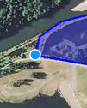

The blue dot is clearly a vertex, or the shape would have no corner here.

Some vertices are a little less obvious, depending on your shape's boundary. In this example, I have a vertex that is almost imperceptible here:

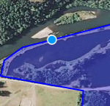

A good way to find vertices like this is to run your mouse pointer along the border without clicking anything. You'll notice that the blue dot follows your pointer's tip closely, but on occasion, and always at corners, it will try to stick, or 'snap' to one spot on the border - this makes it easier to grab vertices to move them. You don't have to get just the right pixel.

Once you've identified the vertex you want to move, simply click on it, drag it where you want it, and release. it will stay there, and you can watch the shape change as you go.

Creating a new vertex:

Creating a new vertex works just like moving an existing vertex, except that you can click anywhere on the boundary (other than on an existing vertex) to create it. Just click on the boundary where it's not quite right, drag the mouse pointer where you want the boundary, and release. Again you will see what the shape will look like in real-time as you move the new vertex.

Once done, be sure to click the 'Save' button to make your changes permanent. You will be allowed to edit them as many times as you want.

### Site Details

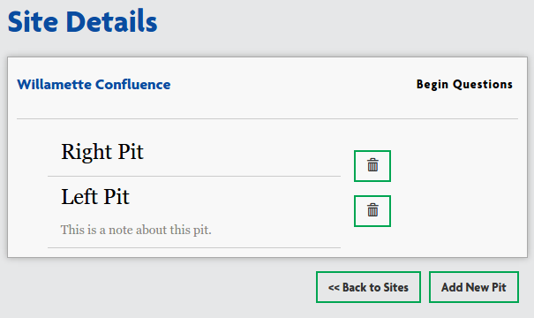

This page is the launching point for managing a site to be assessed for restoration. From here you can click "Add New Pit" to draw and describe the gravel pit mines on the site (covered in the next section), you can see the names of pits you've already added to the site and any notes you included about the pits, you can delete existing pits, you can begin answering questions about the site (details are covered later in this document), or you can click "<< Back to Sites" to return to the All Sites page.

If you have already answered some questions about this site, the "Begin Questions" button will be replaced by a "Go To Summary" button, and a "Continue Questions" button.



While the original "Begin Questions" button will take you to the first question in the series, clicking on "Continue Questions" will take you to your first unanswered question.

"Go To Summary" will take you to your report summary page, which will give you a brief look at how your site is shaping up. Note that if you have not finished answering all of the questions that you have information for, this summary is not necessarily accurate. More on this will be covered in the Report Summary section

### Creating/Editing Pits

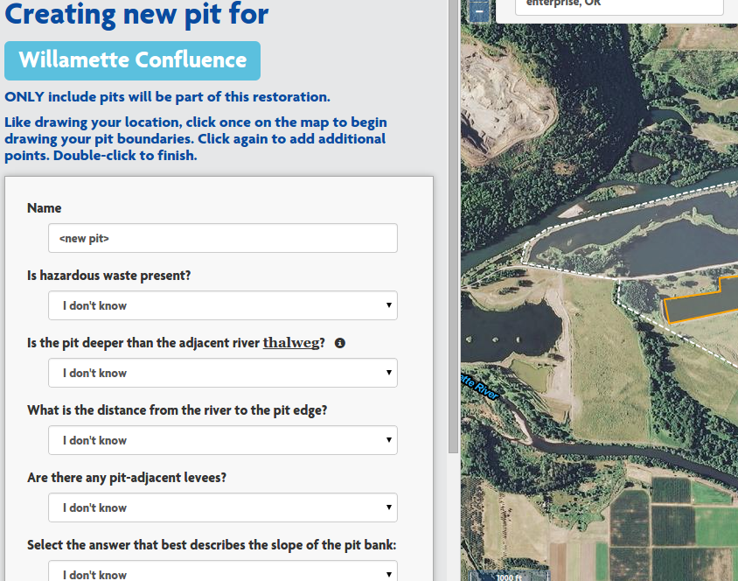

Since this tool is for assessing the restorability of sites with gravel pit mines within the floodplain, it is assumed that your site will have gravel pit mines on it, and your site will not get a good score without them.

Adding a pit to your site is a mixture of answering questions about each pit, and drawing the boundaries of your pit. Apart from naming the pit and adding notes, all of the questions are multiple choice.

Drawing your pit outline accurately is a bit more important than your site boundary, as part of your pit score is related to the size and shape of your pits: values determined by your drawing.

As with creating sites, the pit will not be added to your site until you click on the 'Save' button at the bottom. Editing also follows the same rules covered in the "Editing" section above.

### Survey

By clicking on either the "Begin Questions" or the "Continue Questions" button on a site's Details page, you can access the first unanswered question in the series. However, one you have selected a target site from the All Sites page, you will be able to navigate to any question at any time in the header using the questions menu in the Header (explained above).

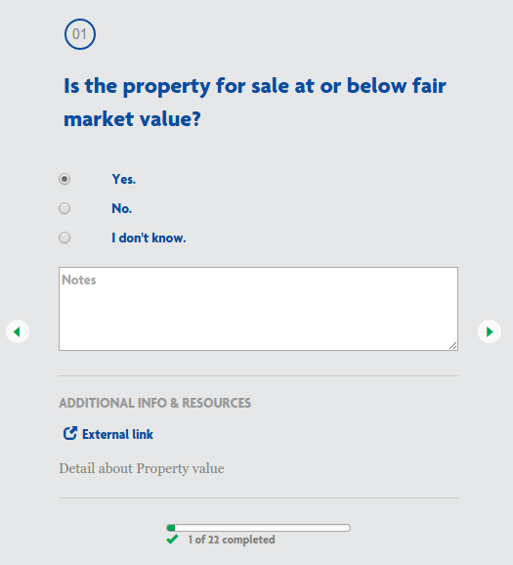

Each question gets its own page. At the top you can see the question number, followed by the question itself. Just below the questions will be the available answers - all answers will be multiple choice.

Each question also allows you to enter in some notes about the question or the answer for your own reference. Sometimes a question may not seem to have a clear answer, and so you will want to return to it after reviewing your materials or the help pages on this site. This notes section will help you maintain your train of thought in these cases. It will not play in to your final score.

Sometimes questions may have additional information or resources to help you fully understand the question. If so, links such as the "External link" shown here will appear below the notes section. There will often be an additional blurb explaining some nuance or terminology in the question below. In this case there is just placeholder text "Detail about Property value".



Navigating between questions is done with the left and right arrow icons on the sides of the left panel. The left arrow will take you back to the previous question (or the details page if on question 01) and the right arrow will take you to the next question (or the report summary page if you are on the last question).



At the bottom of the panel you will find the survey status bar. As you progress through the questions this bar will display your progress so you can have a feel for either how much further you have to go, or if you've answered all of the questions you have answers for, an idea of how much information will not be fed into the model to assess your site.

### Report Summary

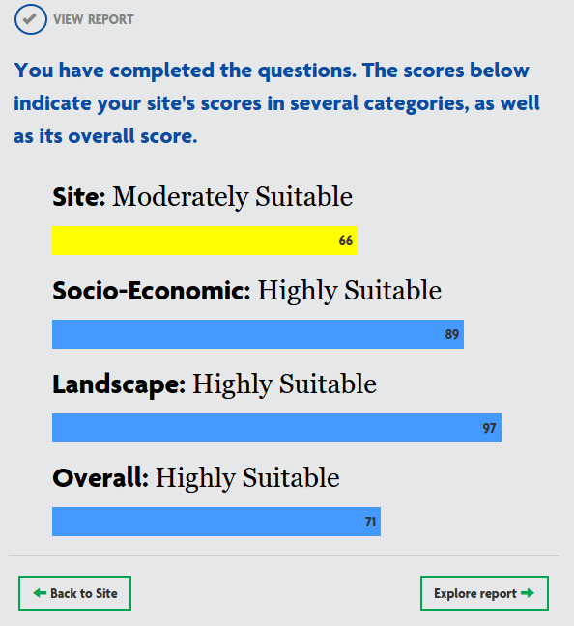

In a site's Report Summary page, you will get a broad overview of how your site was assessed. Your site is scored against 4 metrics: the physical characteristics of the Site itself, Socio-Economic factors to consider in taking on this restoration project, the landscape as a whole, and a final overall score.

Sometimes scores may be a bit surprising, but keep in mind that the scores are based on a Bayesian Belief model which is built to adjust for unknowns. Some answers on some questions will carry a tremendous amount of weight if paired with certain answers for other questions. Due to this variability, it is possible for your "Overall" score to be the lowest of the bunch, not just an average as one would expect. This is why it is important to gather as much information about your site as possible.

From this page, you can either return to the Site Details page via the "Back to Site" button, or you can go on to the detailed "Full Report" with the "Explore report" button.

### Full Report

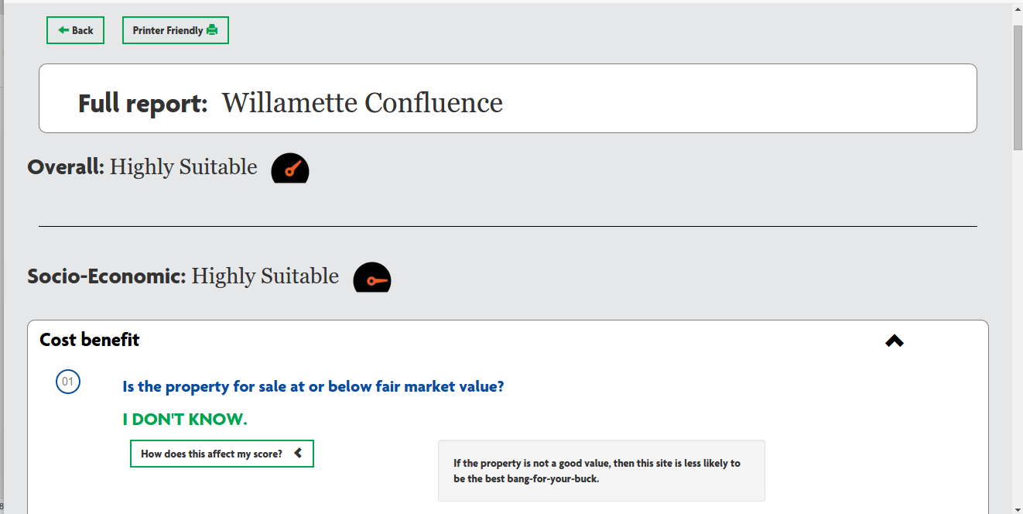

On this page you will be able to dig in and fully understand your score. You can review every answer you gave, and by clicking on "How does this affect my score?" you can get some insight as to why some questions are so important and may carry different weight than others, and how they may relate with other answers to result in your score.

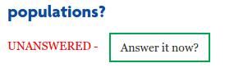

It is possible that you were not able to answer all of the questions, or that you forgot to come back and answer questions you had previously skipped. In the report, those answers will present a button to link you back to the skipped question so you can quickly answer it without digging through the other questions to find it.

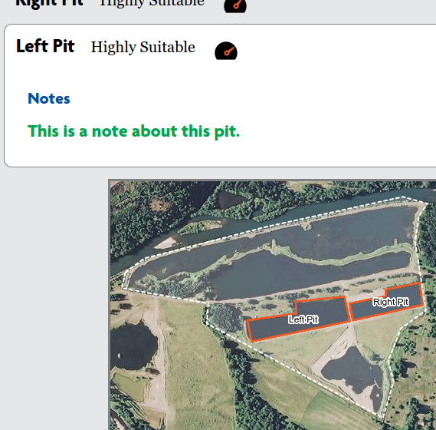

At the bottom of your report, you will find the pit details and a map of your pits included. It is good to remember that the assessment is for the restorability of all pits you list for the site. If your Location score is low, and you see one of your pits has a low score, perhaps you may want to assess restoration of the site without including that pit in the restoration. It is very possible in this case that deleting that pit from your site will raise your score, assuming you have other pits worth restoring on the site.

### Printable Report

From the Full Report page there is a button at the top marked "Printer Friendly":



This button will take you to a new view of the report that is much less stylized, but works very well being printed or saved as a .pdf to share.

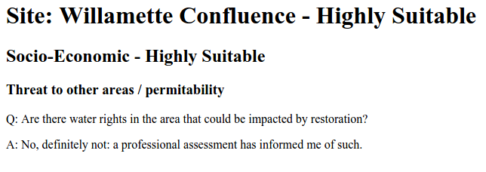

The styles are toned down and the colors are simplified - this will look better on paper and will conserve ink, not to mention that trying to print pages loaded with dynamic content, as the Full Report is, will not go well - to the point where it may be completely unreadable. This format is dependable and despite not being pretty, still contains the same information.

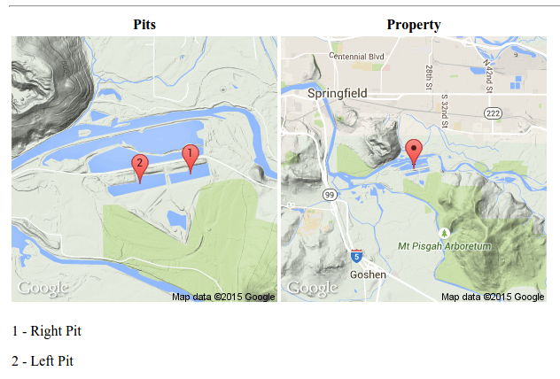

Despite the stripped down style and graphics, the printable page still has the pits and property mapped at the bottom, just in a printer friendly format.

## Site Administration

### Accessing the Admin Site

If you log in to the tool with an account that has administrator priveleges, there is one immediate difference: 'SITE ADMINISTRATION' is now an option in your user menu in the nav bar at the top of the screen.

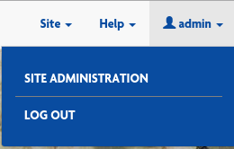

If you believe you are or should be an administrator and you do not see 'SITE ADMINISTRATION in your user menu, contact someone you know who IS an administrator and get your permissions updated. The process to do this is explained in the next section.

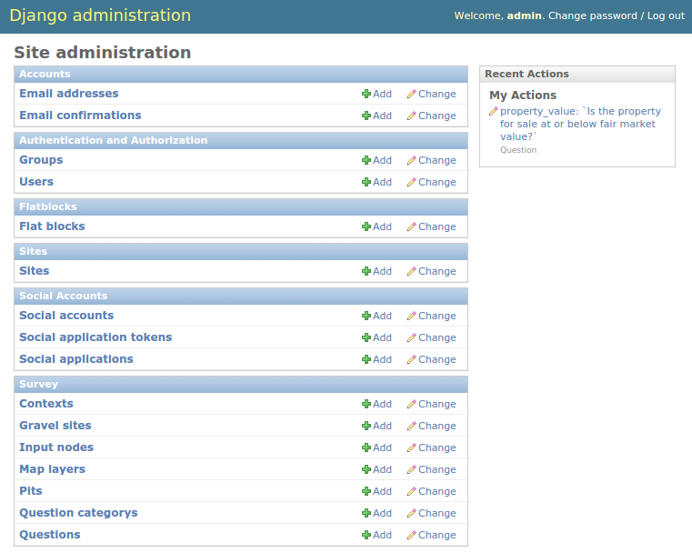

The admin page is where administrators exercise control over the user experience. From this menu they can perform many of the common tasks that this site requires including:

* Creating/deleting accounts (Superusers Only)
* Changing user passwords (Superusers Only)
* Updating webpage content
* Change a user's email address

As seen in the screenshot, administration is organized into 'modules' (the box headers with blue backgrounds) from which you can access the forms you'll need (the blue links with white backgrounds inside each box).

There are three modules that will be of importance while maintaining this site ( only two for non-superusers ) and they each have a section below - the rest should be ignored unless you absolutely know what you're doing.

### Authentication and Authorization

*SUPERUSERS ONLY*

Superusers will have the right to create, edit, and delete user accounts.

Adding an account:

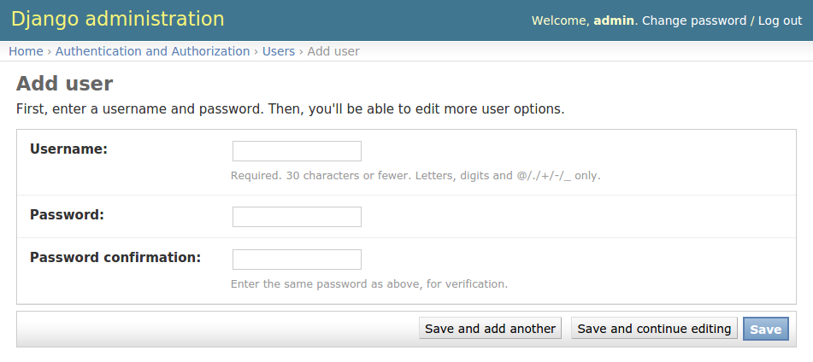

To create a new account, the bare minimum is to give a username and a password. This scenario is unlikely, as anyone can create their own account via the registration process. It is more likely that you are here because you want to create a new Site Admin or Superuser account. Once you've completed this form, click 'Save' to move on the the next steps.

You will now be taken to the 'Edit User' form, which is much more exhaustive. In the first box, you can update the **user's name or password.**

In the second box, you can enter detailed information about the user including **First Name, Last Name, and Email address.** Again, email address is important if the person forgets their password, they can use the site's 'Reset Password' functionality to verify themselves via email.

The permissions form, the third form, is where things start taking a bit more thought. The first three items on the form are checkboxes to assign the new user's privileges:

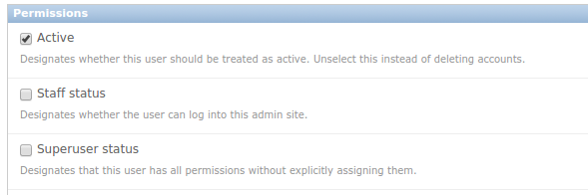

The 'Active' option is selected by default - it is useful in some projects to deactivate users rather than delete their account if you want to maintain information about how many people ever registered, etc...

The 'Staff status' checkbox indicates that a user will have access to the admin pages. If you are NOT checking this box then be sure you have a good reason - non-admins should use the site to register if at all possible.

The 'Superuser status' box indicates whether there should be any restrictions on a user's permissions. Superusers can add/delete/change any form in any module on the admin site with one exception: **IF A SUPERUSER IS NOT ALSO GIVEN STAFF STATUS, THEY CANNOT LOG IN TO THE ADMIN TOOL.** I know that sounds weird, and it is weird, but it's a good thing to know.

You may be noticing a trend: not all users are created are create equal. General public only have permissions to add sites, pits, and answers through the website, and only to their own account. Site Administrators can change some text, but still can't do all of the things a Superuser can. These predefined sets of permissions are called 'Groups':

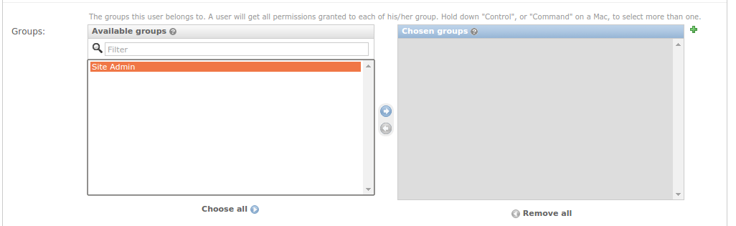

There is no 'Public' group - their permissions are the lowest available. There is not 'Superuser' listed in this form - if the 'Superuser status' checkbox is filled in above, this step and all other parts of the form (except 'Save') are irrelevant. This leaves only the 'Site Admin' group.

To create a 'Site Admin' group member, click on 'Site Admin' in the 'Available groups' box to highlight it like shown above. At this point the 'Right Arrow' button between the two boxes will turn blue. Clicking on the 'Right Arrow' will move the 'Site Admin' group from the 'Available Groups' box over to the 'Chosen groups' box. Once you save this form, that user will have all the rights and privileges of a Site Admin.

Removing group permissions works the same way only with the 'Left Arrow'. You can also choose to use the 'Choose all' or 'Remove all' buttons below.

The green '+' icon at the upper-right corner of the 'Chosen groups' box allows you to define a new group type. This will require some knowledge about specific permissions, which is covered briefly below.

It is possible you will want more control over which permissions a user gets, and if this user's situation is unique (as in, the same exact permissions will not likely be granted other users in the future which would necessitate a new Group) then you can toggle their permissions in the 'User permissions' section:

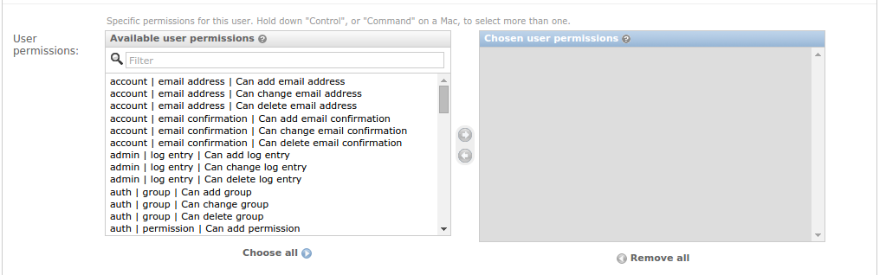

The mechanics for using this form are the same as the groups panel, but there are many, many more options. There is an option for every module, for every form in that module, and an add, a change, and a delete privilege for each of those forms.

For example, suppose you have a user that you want to be able to change flatblocks (described in detail below) but do not want them to have other normal Site Admin permissions like changing contexts. The flat block form is under the flatblocks module, so you would find the following entry in the 'Available user permissions' box on the left: 'flatblocks | Flat block | Can change Flat block'. If you add that permission to the 'Chosen user permissions' box on the right, that user will now see that option (and only that option) when they log in to the site administration.

These permissions are additive - if you want to add 'change user' permissions to a person who was already in the 'Site Admin' group, you only have to add that permission here, it will not remove any permissions that you didn't select.

The next section of the form is 'Important dates'. As the name implies, those dates are (can be) important. Do not change these dates without good reason - they take care of themselves.

Finally the bottom bar is where you can submit this form. It's also where you go to **delete** the user.

Creating a new group works the same as adding specific permissions to a user - select the permissions you want, move them from 'Available permissions' to 'Chosen permissions', give the group a name, and save it. The next time a superuser creates a new user, this name will appear in the list of groups that the user can be added to.

### Flatblocks

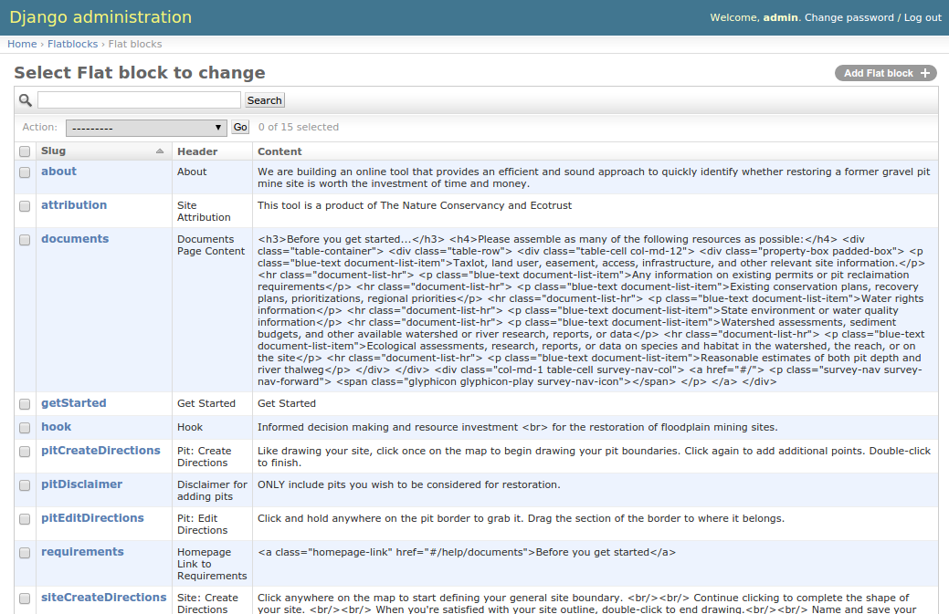

'Flatblocks' are all of the places in the website where the text displayed to public users can be quickly edited and changes. One example would be the 'Get Started' flatblock:



Each flatblock has three parts:

* 'Slug' - which in this case means 'unique id'. It must not be the same as any other flatblocks' slugs. It also is referred to directly in the code, so if this changes, it will not appear in the page anymore.
* 'Header' - A very brief human-readable title explaining what the content is.
* 'Content' - The exact text or html that will be displayed on the site.

In our example, 'Get Started' refers to the 'Get Started' text on the 'Get Started' button on the home page. Currently the 'Content' is 'Get Started' and it appears like this on the site:



Now let's say we went into the admin, and opened up the form to change the content to read "Let's do this!" like so:

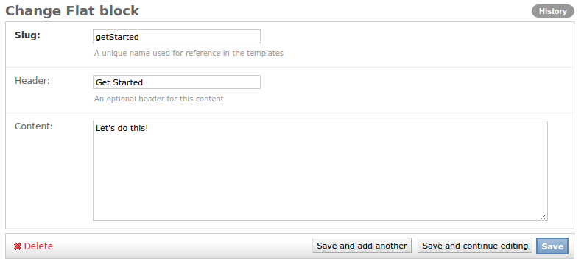

Now if you save your form, then navigate to and refresh the homepage, the 'Get Started' button should now look like this:



NOTE: your personal browser may have cached the old content (remember what it was and assume it hasn't changed). If you don't see your changes reflected on refreshing your browser, try clearing its cache. This is done slightly differently on all browsers, but many of them have the hotkey 'ctrl + shift + r' (for non-macs). If this doesn't do the trick, you may not be changing the text you think you are.

### Survey

The survey module has a series of tweaks that can be made to the site, though most Site Admins should stick to only editing the 'Questions' form. For reference, here are what the other forms are about:

**Contexts** - All questions belong to a category (these can be seen in the 'Questions Menu' in a user's nav bar, and we'll touch on them later). All of these categories, however, are organized into one of three 'contexts':

* + Socio-Economic
  + Landscape
  + Site

You will notice that these 'contexts' relate to all but the 'overall' scores presented in the report and report summary pages. Using their forms, you can change their name or their order that they appear (both in question order or in report order). For more on how order is determined, review the "Order: Context, Category, Question" section below.

**Gravel sites, Input nodes, and Pits** - These are the collections of input values from the users: Every user will create a site ('Gravel site'), each site will contain one or more gravel pit mines ('Pits'), and then each site will have a series of answers to the questions saved ('Input nodes'). Do not change these as they are the user's data that this tool is designed to collect. Users may log in and change their own answers through the tool.

**Question category** - mentioned above, every question belongs to a category, and every category belongs to a context. These are those categories for organizing questions. Each category has a name, a context, and an order. The name you will recognize from the 'Questions Menu' in the Nav bar. The 'order' is used to organize which order the categories' questions will appear within the context. For more on how order is determined, review the "Order: Context, Category, Question" section below.

**Questions** - the questions displayed in the questions portion of the tool. This is a very delicate, and very touchy form that also will likely be a frequent target for change. Because of this, the next section is devoted entirely to it.

### Survey - Questions

The first thing to know about questions is that **they are set in stone.** Adding or removing questions **WILL** break the tool. There are complex calculations going on under the hood that are defined with these **EXACT** questions in mind. That being said, there are parts of the questions that can be edited, some safely, some less so. Also note that Site Admin users will be able to change any field on the question, even the ones that will break the tool. The admin site assumes you know what you're doing, so read this next bit **CAREFULLY**.

Each question has the following fields. This document will try to explain exactly what each one does, and call specific attention to the ones that are good to change, and the ones that are dangerous.

**Name** - This is a 'code-known' name for the question. **THIS MUST NOT CHANGE.** The code looks for this to identify which value to use when calculating the assessment report.

**Title** - This is a brief description of what the question is about. It will show up in the 'Question Menu' drop-down from the user's nav bar, on the question page, and in the reports. It's safe to change, but not likely to need any edits.

**Question** - The question that will be printed on the question page. While it is possible you will want to make some edits to the question text: **THE CONTEXT OF THE QUESTION MUST NOT CHANGE.** If changing how you ask the question is going to change how the user answers (assuming they understand both questions clearly) then your edit is NOT APPROPRIATE. If the edit is just to clarify the original intent of the question, then it is a good change.

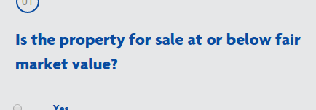

**Detail** - This is a blurb of text printed beneath the question and notes section. This is a good place to clarify uncommon words like 'thalweg', ideas like a '100 year floodplain' or extrapolate on the purpose of or background behind the question.

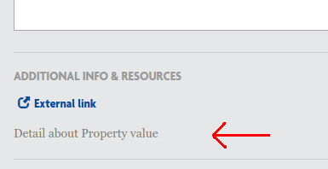

**Order** - Order determines when the question will be asked *relative to other questions in its category.* For more on how order is determined, review the "Order: Context, Category, Question" section below.

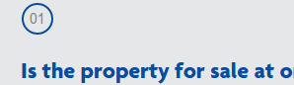

**QuestionCategory** - A drop-down list of the available categories. **DO NOT CHANGE THIS OR ADD NEW CATEGORIES.**

**Image** - If an image file will be helpful in explaining the question, a diagram, examples illustrating a concept, etc..., It can be uploaded and will appear as a 'View Image' link underneath the question with the external links and supplements:

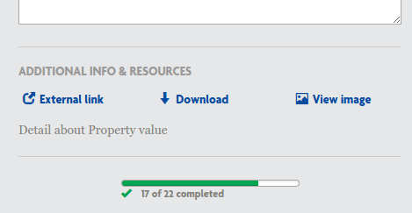

**Supplement** - A downloadable file that may assist the user in accurately answering the question. It appears as 'Download' beneath the question as in the image above.

**ExternalLink** - Sometimes seeing another website for reference on an issue or question will clarify things. In these cases, as helpful link can be provided as 'External Link' beneath the question in the image above.

**Impact** - Explanatory text covering how a user's answer is considered in the assessment. It isn't shown to the user until the report and it should illustrate which situations make for better restoration candidates, and how important this answer is in considering the project.

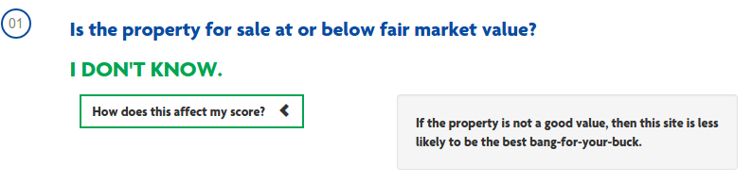

**Choices** - **DO NOT TOUCH THIS.** If you look, the current content of this box includes the brackets and curly-braces that suggest 'computer code'. In this case, this is JSON input given to the webpage to present the users with their multiple choices. Losing so much as a comma from this field will ruin the display of this question, making it unanswerable.

### The Other Modules (Briefly)

**Accounts** - When users create their own account, their email addresses (if given) are tracked under 'Email addresses'. If users confirm the email that they were sent, that record gets stored in 'Email Confirmations'. In the case that a user reaches out and says they need to change email addresses and can prove that they have control of their currently set email address, thenthis would be where to update it so they can continue to change their password when necessary.

**Sites** - A setting the framework uses to fill in many templates. **DO NOT CHANGE THIS.**

**Social Accounts** - This is a feature of the authorization tool we use. One of its feature is that (with work) users can use other social media logins to sign in to the site. This practice is not implemented for this site.

### Order: Context, Category, Question

All of the survey questions belong to a Question Category. All of the Question Categories belong to a Context. This hierarchy was designed for the assessment of the user's answers, but is also helpful in organizing the questions into a logical order for presentation to the user.

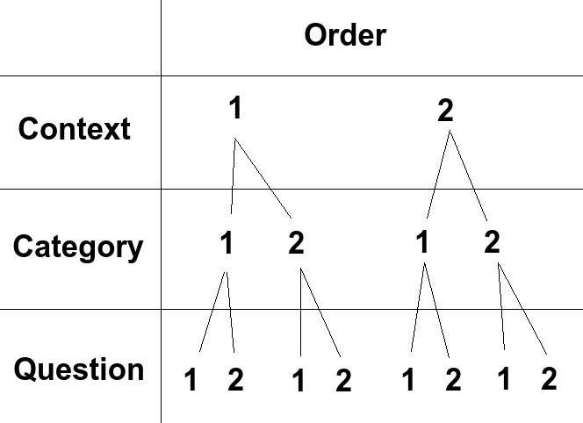

Imagine the following Scenario:

Context Socio-Economic has order value '1.0'

Context Landscape has order value '2.0'

Any question that belongs to a question category the belongs to the 'Socio-Economic' context will be displayed before any question that belongs to a question category that belongs to the context 'Landscape', regardless of either the question's or the question category's order value. Context comes first for ordering.

Category 'Cost Benefit' belongs to Context 'Socio-Economic' with an order value of '1.0'

Category 'Threat to other areas' also belongs to Context 'Socio-Economic' with an order value of '2.0'.

Category 'Conservation value' belongs to Context 'Landscape' with an order value of '1.0'

In this case, using the established context order values from before, any question that belongs to the category 'Cost Benefit' will be shown before any question associated with category 'Threat to other areas'. Also, even though it's own order is lower than that of the other two, because category 'Conservation value' belongs to context 'Landscape', its questions will be displayed after the other categories' questions.

From here, you could make your own examples of different questions with different orders belonging to different categories and working out what their order would be. The lesson here is don't just change the order of a question to 0 and expect it to be the first question displayed to a user.